ASSIGNMENT-1

Question 1

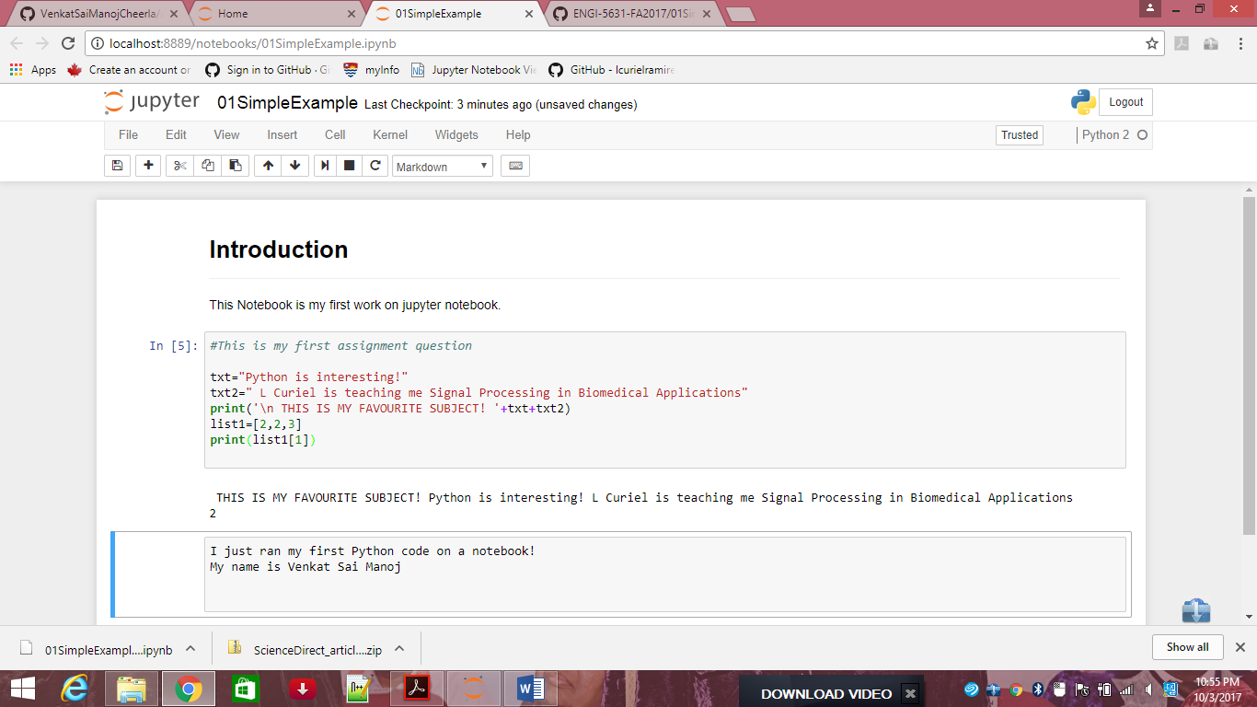

Question 2

1. Noise threshold is 57.05

As shown below at x=4.5010MHz the y=57.09 which is the noise threshold

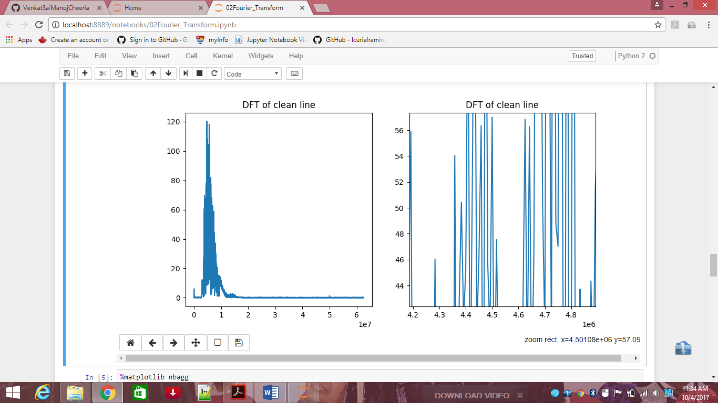

2.

3.

4. Total number of noisy lines code

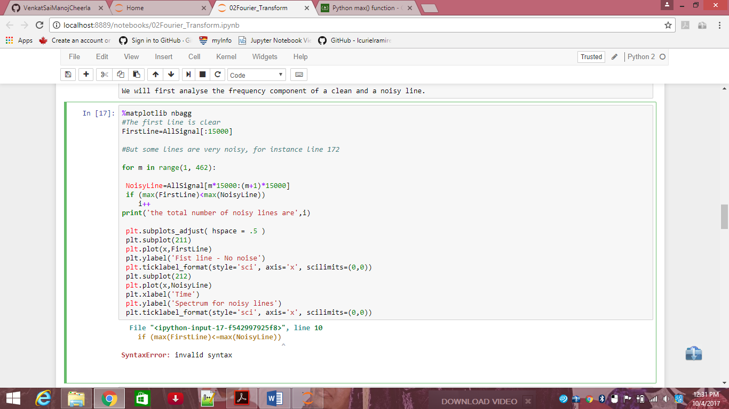

5. Spectrum for noisy lines

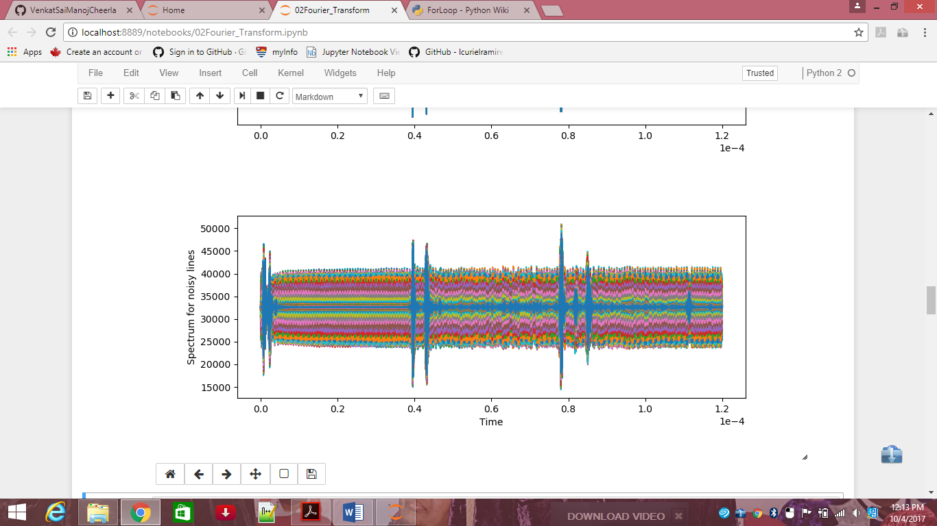

Question 3

If an input signal is passed through 3 vs a 9 average filter, the output signal gets attenuated ie, there will be a decrease in the amplitude of the signal and there is also a phase difference between input and output signals.

At omega=1,

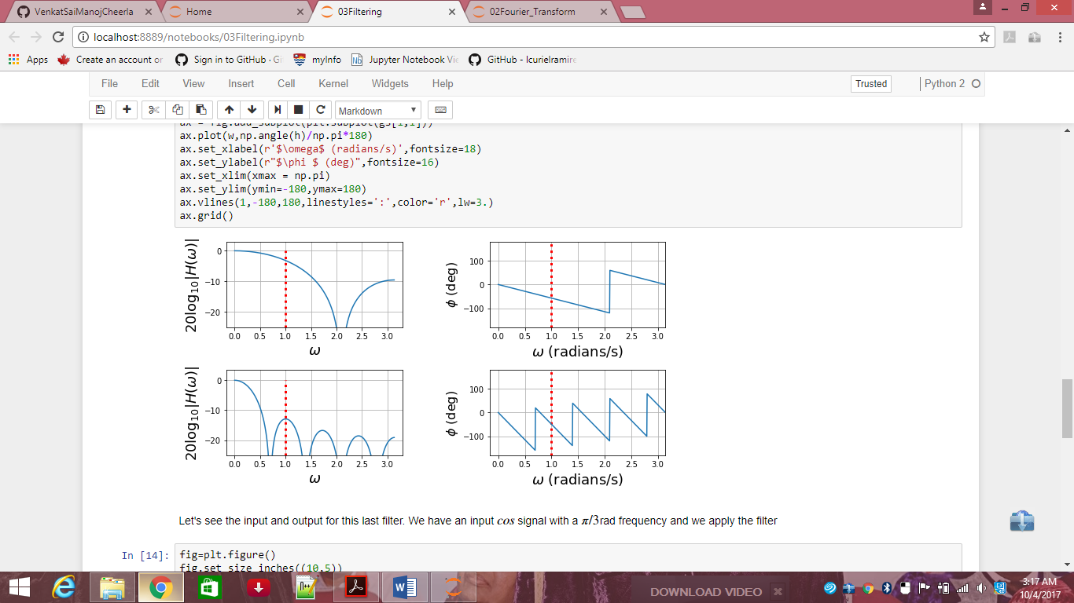

The output signal is

